**tNo identifying information**

**Email Address:** [overheadinitiative@gmail.com](mailto:overheadinititiave@gmail.com)

**Password:** soldering101

**Title:**

The OMAR/Team Overhead

**Our Mission:**

The Overhead Initiative strives to assist those who are visually impaired in avoiding overhead objects when outside.

**Description:**

Our product is a hat which can detect overhead objects, designed for our visually impaired individuals who struggle to identify these objects even with use of a cane.

**Technical Information:**

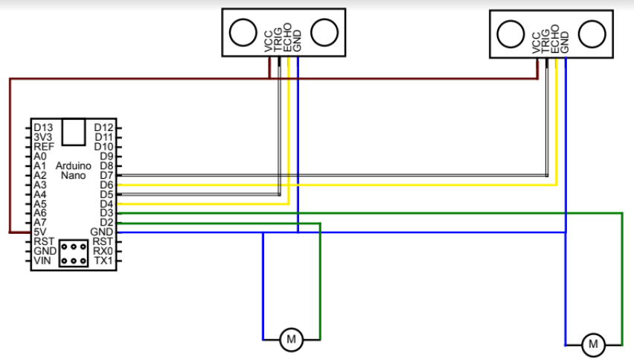

**Images of Prototype:**

**Current Progress:**

Soldering hat (2nd prototype)

Fundraiser Plan:

1. Start with simple fundraiser - crowdsourcing from family and friends, use it as a backup source of compensation
2. Work on main source of compensation - club/school fairs + sponsors
3. Set up website + social media account for donations + promotion
4. Set up a goal to reach considering costs for materials, licensing/trademark, etc ($500 baseline?)